National University of Computer and Emerging Sciences

(Islamabad Campus)

Department of Computer Science
Signature of Invigilator: ______________ Serial No:_________
EE-105 Computer Logic Design
Final Examination (Spring 2013)
Instructor(s):
Dr Ayub Alvi, Ms Mehreen Alam, Mr Adnan Saeed
Monday May 27, 2013
Total Marks: 105 Time Allowed: 3 hour
Please read the instructions carefully:
- Understanding the question paper is also part of the exam, so do not ask any clarification.
- Solve questions in the space provided, or if you need more space write on the back side of the paper and clearly mark question and part number etc.
- It is a CLOSED book/notes exam.
- Calculators are NOT allowed.
- Write your name and roll number on each page.
- The question paper is printed on both sides of the pages.
- Use permanent ink pens only. Any part done using soft pencil will not be marked and cannot be claimed for rechecking.

Roll No: _________ Name: _________________________ Signature____________ Sec: ___
Question | 1 | 2 | 3 | 4 | 5 | 6 | 7 | 8 | Total
Total Marks | 15 | 9 | 15 | 15 | 15 | 10 | 13 | 13 | 105
Marks Obtained

Vetted By: _______________________ Vetter Signature: ____________________

Question # 1[15 = 5,5,5]
- Complete the following table :
Binary | Octal | Decimal | Hexadecimal
1011.0011
 |  | 29.99
 |  |  | 1B

- Calculate the following:
- 11001 plus 101

- 11010 minus 10101 using 2’s complement representation

- 1101 times 1001

- 101101 divided by 110

- Complete the following table, Use binary numbers with a sign bit plus 5 bits for the magnitude.
Decimal | Sign Magnitude | Two’s Complement | One’s Complement
-11
6
-1

Question # 2[9 = 3, 6]

- Construct a 5-32 line decoder with two 4-16 line decoders with enable. Use block diagram for components.

- For the following circuit, complete the table below assuming ‘Carry In’ is zero.
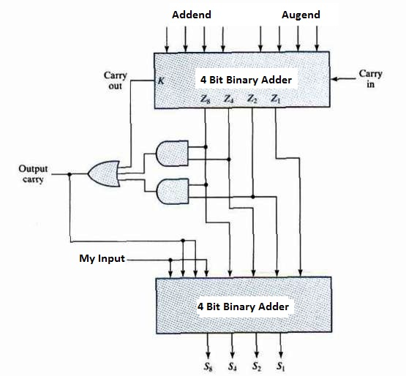

My Input | Addend | Augends | Z₈Z₄Z₂Z₁ | S₈S₄S₂S₁ | Output Carry
0 | 0111 | 0111
1 | 1110 | 0110

Question # 3 [15 = 6,9]
- Write the characteristic equations and draw the excitation tables for D, T and JK flip-flops.

- A sequential circuit has two JK flip flops A and B, two inputs x and y. The FF input equations and circuit output equations are:

$$J_{A}=Bx+B^{'}y^{'}$$
$$J_{B}=A^{'}x$$
$$K_{A}=B^{'}xy^{'}$$
$$K_{B}=A+xy'$$

- Draw the logic diagram of the circuit.
- Tabulate the state table.
- Draw the state diagram

Question # 4 [15 = 10,5]
- A sequential circuit has three flip-flops, one input and one output. Its state diagram is shown in figure on the right.

- Derive State Table from the State Diagram. Treat the unused states as don’t cares.
- Derive Sate Equations from the State Table using D flip flops.
- Draw the resultant circuit.
- Does the circuit malfunction for taking the unused states as don’t cares? Justify.

- Can the number of states in the table below be reduced? If yes, draw the reduced state table, else state reasons.
 | Next State |  | Output
Present State | X=0 | X=1 | X=0 | X=1
a | f | b | 0 | 0
b | d | c | 0 | 0
c | f | e | 0 | 0
d | g | a | 1 | 0
e | d | c | 0 | 0
f | f | b | 1 | 1
g | g | h | 0 | 1
h | g | a | 1 | 0

Question # 5 [15 = 8, 3, 4]
- Design a synchronous counter with T-flip flops that goes though the following binary repeated sequence: 0,2,3,4,5,6. Consider the unused states as don’t cares. Show that when binary states 001 and 111 are taken as don’t care conditions, the counter may not operate properly.

- Draw (do not design) and label the logic diagram for a 3-bit ripple counter implemented with T flip flops.

- Design a 3-bit synchronous counter (0, 1,2,3,4,5,6,7...) with J-K flip flops.

Question # 6 [10 = 5,5 ]

- Given four D flip-flops and four 4 x 1 multiplexers construct a 4-bit universal shift register that operates according to the following function table using mode selection inputs S₁ and S₀. (Draw appropriate lines enabling the register to work according to the table given below)
S₁ | S₀ | Register Operation
0 | 0 | Parallel load
0 | 1 | Shift left
1 | 0 | No change
1 | 1 | Shift right

4 x 1
Mux
3 2 1 0

D FlipFlop
D
D FlipFlop
D

D FlipFlop
D
D
D FlipFlop
D
D
4 x 1
Mux
3 2 1 0

4 x 1
Mux
3 2 1 0
4 x 1
Mux
3 2 1 0

A₀
A₁
A₂
A₃
S₁
S₀

- In the diagram below, assume that the 4-bit shift register A contains 1001 and Shift register B is empty (0000), What will be the contents of register A and Register B after three clock cycles given that Serial Input for Register B is connected to a logic high.
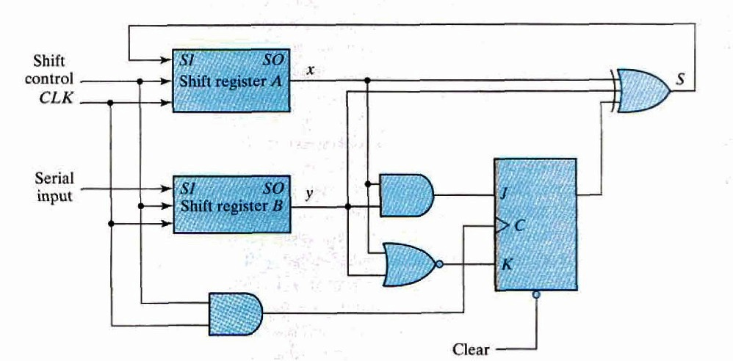

Question # 7 [13 = 2,2,3,2,4]
Random Access Memory (RAM) is a collection of storage cells in which time taken to access information from any location remains the same.
- How may 32K x 8 RAM chips are needed to provide a total memory capacity of 256K x 8?
- How many address lines are required to access 256K bytes?
- How many of these lines are directly connected to the address lines of all the chips?
- How many address lines must be decoded for the chip select inputs? Specify the size of the decoder.
- Label the following diagram of a 4x4 RAM
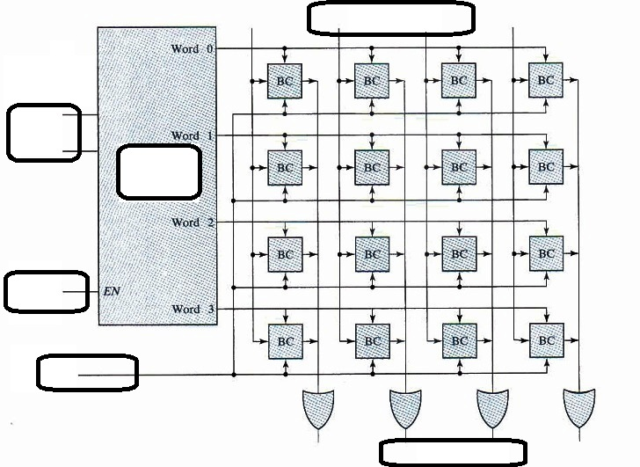

Question # 8 [13 = 4,4,5]
Hamming Error Detection and correction scheme is used for four data bits: D3, D5, D6, D7 together with three parity bits: P1, P2 and P4. Assume the data word 0010.
- Evaluate the 7-bit composite code word.
- Evaluate three check bits C4, C2 and C1 assuming no error.
- Assume an error in bit D5 during writing into memory. Show how the error in the bit is detected and corrected.

